
Company
Logotype

Cone Beam Computed Tomography- Report



Porur Dental X-rays & CBCT

Patient Name : Mrs. Sangamithra | Date of Report : 13.05.2024
Age/ Gender : 44 years/ Female | Region of Interest : CBCT Mandible
Referring doctor: 32 Dental | Indication : Impacted tooth 48
Clinical Notes: Nil
PATIENT INFORMATION

CBCT- Mandible provided
CBCT – IMAGE DETAILS

RADIOGRAPHIC INTERPRETATION

- The long axis of 48 appears to be horizontal/ perpendicular to the long axis of the adjacent 47 tooth.
- The crown of 48 is present such that the disto-coronal portion lies along the alveolar ridge.
- Distance between the crown of 48 and the Inferior Alveolar Nerve canal: 3.87 mm
- Distance between the radicular portion of 48 and the Inferior Alveolar Nerve canal: in contact.

RADIOGRAPHIC IMPRESSION

- Horizontally Impacted tooth: 48.

Kindly correlate with clinical findings


IMAGES FOR REFERENCE

RECONSTRUCTED PANORAMIC VIEW
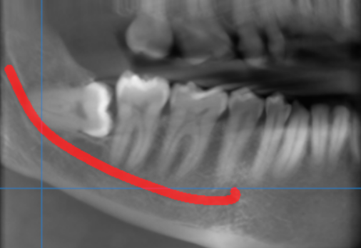

3-DIMENSIONAL VIEW
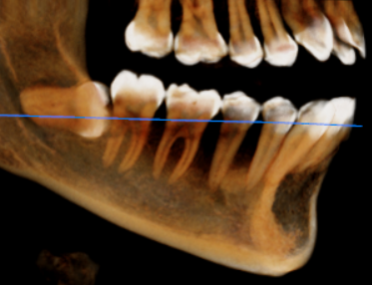

CROSS SECTIONAL VIEW

48 region- and its relation to inferior alveolar nerve canal | 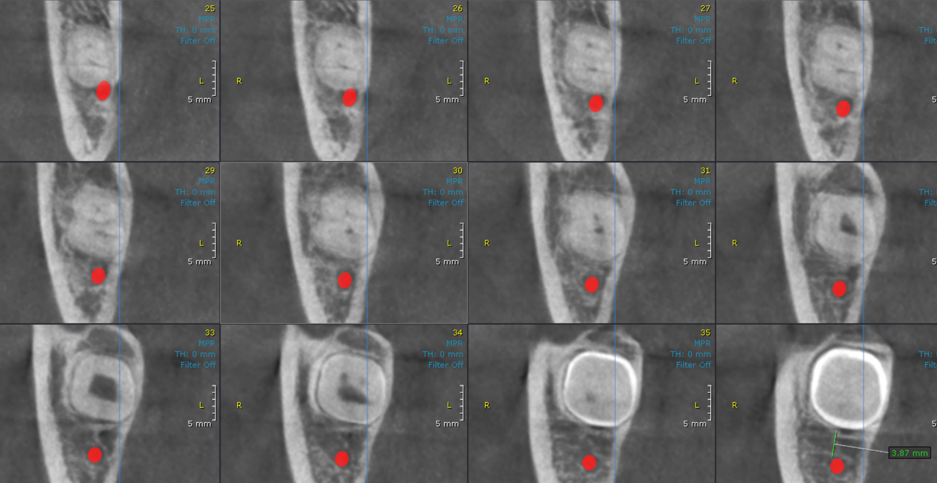

**** End of report ****

